INTRODUCTION DAY FOR INTERNATIONAL STUDENTS

Friday, 28.09.2018
Place: Building D-20, auditorium 10 ACD, 8 Janiszewskiego Street
Time:
9:00 Opening of the ceremony
9:30 Official welcome by the University Authorities
9:40 Presentation of Wroclaw University of Science and Technology
9:50 Introduction of Faculty Coordinators and representatives of the Office of International Affairs
15 minutes break
Presentations:
10:30 Department of Foreign Languages
10:40 Department of Polish Language
10:50 Safety in Wrocław
11:10 Department of Dormitories
11:20 Career Office
11:30 Main Library
11:40 Erasmus Student Network (ESN)
11:50 Student Association OFF-ROAD
12:05 KoNaR Scientific Circle
12:15 PWr Racing Team
12:25 Students’ Forum
12:45 Invitation to the "Polish Cinema for Beginners" at the Nowe Horyzonty cinema
13:00 Lunch at the Student Culture Zone (Strefa Kultury Studenckiej)
14:00 Meeting ESN students before going to the Faculties (in front of the Student Culture Zone)
14:30 Meeting at the Faculties

Meetings with faculty coordinators (BE PUNCTUAL):
14.30 Faculty of Architecture W1 – building E-1 room 201
14.30 Faculty of Civil Engineering W2 – building C-7, room 505
14.00 Faculty of Chemistry W3 – building C-6, room 10
14.00 Faculty of Electronics W4 – building C-5, room 1
14.30 Faculty of Electrical Engineering W5 – building D-20 room 408
14.30 Faculty of Environmental Engineering W7 – building D-1, room 11.3 (Dean’s Office)
14.30 Faculty of Computer Science and Management W8 – building B4, room 409
14.30 Faculty of Mechanical and Power Engineering W9 – hall of the place when lunch will be served
14.30 Faculty of Mechanical Engineering W10 – building B-4, room 2.41
14.30 Faculty of Fundamental Problems of Technology W11 – building A-1, room 222
01.10.2018 at 10:00 – Faculty of Applied Mathematics W13 – building C11, room 106
Wroclaw University of Science and Technology’s Campus
D-20 room 10 ACD, 8 Janiszewskiego Street
C-18 Student Culture Zone (Strefa Kultury Studenckiej)
12 Hoene-Wrońskiego Street
Admission Office is located in building C-13, room 1.14
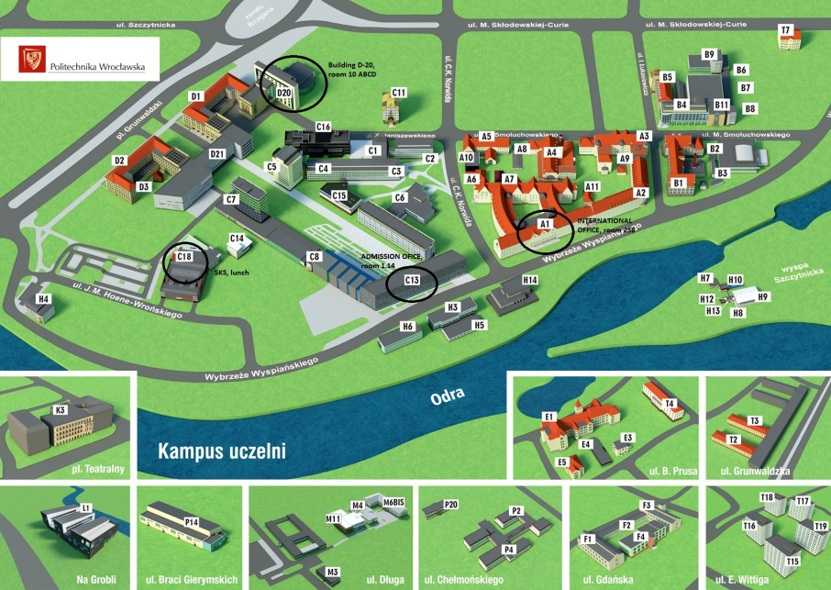
Office of International Affairs is located in building A-1, rooms 255-256

